Author: Cédric Vincent

**Vohou Vohou**

Vohou Vohou refers to a group of artists from Ivory Coast who came together at the beginning of the 1970s. It mainly included Youssouf Bath, Théodore Koudougnon, Mathilde Moreau, Kra N’Guessan and Yacouba Touré. Vohou emerged as a movement of pictorial research in which 'materials of retrieval' and abstract painting could be made to redefine a new specificity within the multifarious identity of the Ivoirian artist. Kra N'Guessan defines Vohou as "neither a style, nor a school, it is a spirit". Vohou artists aimed to emancipate themselves from the western canon taught in the Abidjan art school, and challenged the classical painting methods. They drew inspiration on the cultural traditions of West Africa (glyphs, esoteric symbols), and used recycled materials in their immediate environment (chewed paper, beads, strings, bird feathers, wood, sand etc.) as alternatives to expensive and imported materials such as canvas and oil paints). They painted with recycled objects and natural pigments mixed with organic materials. At the same time, they renounced any tendencies toward figuration in order to develop a radical dialogue with abstract painting. This principle ofself-sufficiency referred to an autochthonousposture while formulating in terms of an artistic avant-garde. "We want to africanize Ivorian painting!" wrote Youssouf Bath in the manifesto *La Révolution Vohou*. In that way, the Vohou movement appears as a belated realisation of artistic movements that escorted the idea of ​​national culture since Independence, such as the concept of Natural Synthesis founded by the painter Uche Okeke in Nigeria.

The Vohou artists, for the most part, had received an academic training both in Paris and Abidjan. However, the birth of the movement was related to the Black Caribbean School (*Ecole Négro-Carraïbe*) created at the end of the sixties by three Caribbean artists based in West Africa, in order to remobilise the strengths of their "African heritage". One of them, Serge Hélénon, a native of Martinique and professor at the art school in Abidjan, was a supporter of Negritude and wished to be rid of the academic trend inherited from the colonial period in art teaching. He encouraged his students to use their material and techniques with the greatest freedom. The term Vohou is itself ironical. In Gouro language, it means "putting anything and everything together", and also refers to the mixture that the healer rubs on a patient's body to restore health.

The movement met with popular and critical success in the mid 1980s because of the active support of the French Cultural Center. However, it could not avoid the development of its own form of academism, which it had sought to escape. The Vohou legacy was kept alive thanks to artists like Mathilde Moreau, Togba Issa Kouyaté, Tiebena Dagnogo and Yacouba Touré through the Daro Daro movement. Daro means "Victory" in Adjoukrou language. This artistic movement came out in 1996, claiming the freedom to create against prejudicesand unencumbered by the public. It affirms the "independence of the spirit" against the art market and the conventional exhibition venues. Furthermore, the term Vohou expanded its semantic field beyond visual arts toward literature (the writings of Ahmadou Kourouma), informal architecture and music.

Further readings :

[*Cahier de l'ADEIAO* n°11 - Vohou-Vohou - Hommage à Véronique Wirbel](http://www.adeiao.org/publication/vohou-vohou.html), 1991.

Boisdur de Toffol M-H. "L'école Négro-Caraïbes et le mouvement Vohou-Vohou" in N'Goné Fall et Jean-Loup Pivin (eds.) *Anthologie de l'Art Africain du XXème siècle*, Paris: Revue Noire Editions, 2001, 238-241.

## Konaté Y. "Art and Social Dynamics in Côte d'Ivoire: The Position of Vohou-Vohou" in Gitti Salami and Monica Blackmun Visona (eds.), *A Companion to Modern African Art*, Wiley-Blackwell, 2013, 371-388.

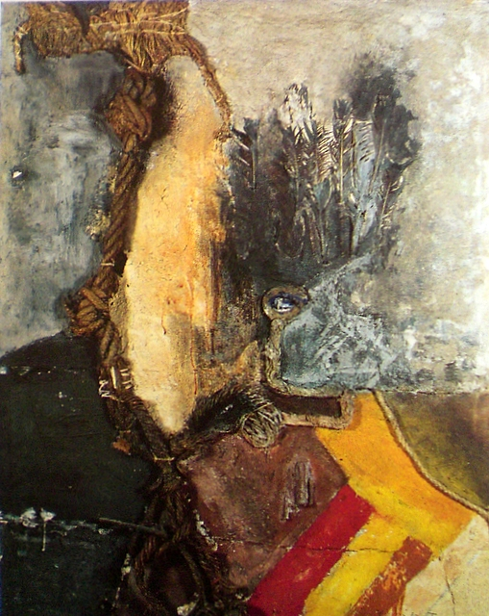

Youssouf Bath, no title - mixed media, 1972-75, 129 x 101 cm / credit ADEIAO

[www.adeiao.org/cote-ivoire/youssouf-bath/bath-sans-titre.html](http://www.adeiao.org/cote-ivoire/youssouf-bath/bath-sans-titre.html" \t "_blank)